**Frontend Project Report**

on

# Ecommerce Shopping Site

# Using HTML, CSS and JavaScript

# Bachelor of Engineering

## IN

**COMPUTER SCIENCE AND ENGINEERING**

**Submitted by:**

**Abhinav Rawat (Roll no:2110990055)**

**Group No: G5**

**Under the supervision of**

**Mr. Lavish Arora, CSE Dept.**



**CHITKARA UNIVERSITY INSTITUTE OF ENGINEERING AND TECHNOLOGY**

**Rajpura, Punjab**

## Department of Computer Sc. & Engineering

### ACKNOWLEDGEMENT

We would like to extend our heartfelt gratitude to the individuals and organizations who played a significant role in the successful completion of our college front-end project developed with JavaScript, HTML, and CSS. Their invaluable support and contributions were instrumental in the creation of this project.

We would like to thank:

Our Faculty and Instructors: Our college faculty and instructors who provided us with guidance, knowledge, and the opportunity to explore and apply front-end development skills. Your support and mentorship were indispensable throughout this project.

Open-Source Community: The open-source community, which provided an array of resources, libraries, and tools that made the development process smoother and more efficient. We greatly appreciate the open-source contributions that fueled our project.

College Support Services: The college's support services, including the library, IT department, and administrative staff, who made resources, facilities, and technical assistance available to us during the course of this project.

This project allowed us to apply the knowledge and skills we acquired during our college education. It was a valuable learning experience, and we are grateful for the opportunities it provided.

We are committed to continuous improvement and the pursuit of knowledge in the field of front-end development. This project marks the beginning of our journey, and we are excited to take what we've learned into our future endeavors.

Thank you to everyone who contributed to this project's success.

Sincerely,

Abhinav Rawat

Chitkara University

CONTENTS

----------------------------------------

Acknowledgement……………………………………………………………………….. i

Introduction………………………………………………………………………………..ii

Goal and Challenges…………………………………………………………..iii

Project Overview……………………………………………………………….. iv

Why choose ELECTRONICS……………………………………………….. v

Future Scope……………………………………………………………………….. vi

**CHAPTER 1: INTRODUCTION**

**1.1 Objective:**

Welcome to our college front-end project, a showcase of our skills and knowledge in web development. This project was created using JavaScript, HTML, and CSS to demonstrate our ability to design a user-friendly and visually appealing website. Our primary focus was on delivering an exceptional user experience while applying best practices in front-end development.

This project allowed us to apply what we've learned and gain practical experience in the field. It reflects our dedication to web development and showcases our problem-solving and skills. In the following sections, we'll delve into the project's features and technologies used to bring it to life. Thank you for joining us on this journey through our project.

* 1. **Introduction to technology used to make project:**

To develop this project, HTML has been used majorly used where different methodologies and tools were applied. Vs Code was the greatest help in developing the above project. More on the technologies and methods used for the project can be seen below:

**HTML:** HTML stands for Hypertext Markup Language. It is the standard markup language used to create and structure content on the World Wide Web. HTML is the backbone of most web pages and is used to define the structure, elements, and layout of a web page, including text, images, links, forms, and multimedia.

HTML uses a system of tags to mark elements on a web page. These tags provide instructions to web browsers about how to display the content. For example, you can use HTML tags to create headings, paragraphs, lists, links, and more.

**CSS:** CSS stands for Cascading Style Sheets. It is a stylesheet language used for describing the presentation and visual design of web pages written in HTML and XML. CSS allows web developers to control the layout, formatting, and appearance of elements on a web page, such as text, images, links, and more.

CSS achieves this by defining rules that specify how HTML elements should be displayed. These rules consist of selectors and declarations. CSS provides a wide range of properties and values that can control everything from colors and fonts to spacing, borders, and positioning. It allows web developers to create visually appealing and responsive web designs while keeping the HTML content separate from its presentation. This separation of content (HTML), presentation (CSS), and functionality (JavaScript) is a fundamental concept in web development, known as the "separation of concerns."

**JavaScript:** JavaScript is a versatile and widely used programming language primarily employed in web development but also increasingly used in other areas, such as server-side development and mobile app development. JavaScript allows developers to add interactivity, manipulate the Document Object Model (DOM), and enhance the functionality of websites and web applications.

Key features and uses of JavaScript include:

* Client-Side Scripting: JavaScript is primarily used on the client side of web development. It runs in the user's web browser, allowing developers to create dynamic and interactive web pages. It can respond to user actions, validate forms, update content, and much more.
* DOM Manipulation: JavaScript can access and modify the Document Object Model (DOM), which represents the structure and content of a web page. This enables dynamic content updates and interaction with HTML and CSS elements.
* Event Handling: JavaScript is used to respond to various events, such as clicks, keyboard input, and form submissions. This allows for user-friendly interfaces and responsive web applications.
* AJAX (Asynchronous JavaScript and XML): JavaScript is essential for making asynchronous requests to web servers, allowing data to be loaded and updated without requiring a full page refresh. This technology is commonly used to create responsive, real-time web applications.
* Cross-Browser Compatibility: JavaScript is supported by all major web browsers, making it a suitable choice for web development. However, developers often use libraries and frameworks to address browser compatibility issues and streamline development.
* Server-Side Development: With the advent of technologies like Node.js, JavaScript can also be used on the server side to build server applications. This enables full-stack JavaScript development and simplifies the development stack for many projects.
* Front-End Frameworks: Several front-end JavaScript frameworks and libraries, such as React, Angular, and Vue.js, have gained popularity for building user interfaces and single-page applications. These frameworks provide a structured approach to building complex web applications.
* Back-End Development: JavaScript is used on the server side, along with Node.js, to create server applications and APIs. This allows for a consistent language and toolset throughout the entire web development stack.

JavaScript is a fundamental tool for modern web development, and its versatility and widespread use have made it an essential skill for web developers. It continues to evolve, with new features and improvements being added to the language and its ecosystem to meet the demands of modern web applications.

**VS Code:**



Figure 5: VS Code

VS Code, short for Visual Studio Code, is a free and open-source code editor developed by Microsoft. It is widely used by developers for various programming languages and offers a rich set of features that enhance productivity and facilitate efficient coding.

Here are some key aspects and features of VS Code:

1**. Lightweight and Fast:** VS Code is designed to be lightweight and fast, providing a smooth and responsive coding experience. It uses minimal system resources and has quick startup times, making it suitable for both small and large projects.

2**. Cross-Platform Support:** VS Code is available for Windows, macOS, and Linux, allowing developers to use the same code editor across different operating systems. This ensures consistency and flexibility for development teams working on different platforms.

3. **Integrated Development Environment (IDE) Features:** Despite being a code editor, VS Code offers many IDE-like features. It provides code completion, syntax highlighting, linting, debugging capabilities, version control integration (such as Git), and more. These features enhance productivity and streamline the development process.

4**. Extensibility:** VS Code has a vast and active extension ecosystem that allows developers to customize and extend the functionality of the editor. Extensions are available for various purposes, such as language support, themes, code snippets, and integration with third-party tools and services.

5**. Integrated Terminal:** VS Code includes an integrated terminal, enabling developers to execute commands, run scripts, and interact with the command-line interface without leaving the editor. This eliminates the need to switch between the editor and an external terminal window.

6**. Version Control Integration:** VS Code seamlessly integrates with popular version control systems like Git, providing features like source code management, commit history visualization, and branch management. Developers can perform version control operations directly within the editor.

7. **Debugging Support:** VS Code offers powerful debugging capabilities with built-in support for various programming languages. It allows developers to set breakpoints, inspect variables, step through code execution, and track down and fix issues in their applications.

8**. IntelliSense:** VS Code provides intelligent code completion and suggestions, known as IntelliSense. It analyzes the code context and offers relevant suggestions, reducing manual typing and helping to catch errors early.

9**. Customization and Theming:** VS Code allows users to customize the editor's appearance, including themes, icon sets, and layout configurations. Users can choose from a variety of pre-installed themes or install additional themes from the extension marketplace.

10**. Remote Development:** VS Code includes remote development extensions that enable developers to work on a remote machine or container directly from the editor. This feature is particularly useful when developing on remote servers or in containerized environments.

Overall, VS Code has gained popularity among developers due to its flexibility, performance, and extensive customization options. Its broad language support and extensive marketplace of extensions make it suitable for a wide range of programming tasks and project types.

**CHAPTER 2: GOALS AND CHALLENGES**

**3.1 Goals:**

* **User-Friendly Interface:** Develop a responsive and user-friendly interface that allows customers to easily browse products, view details, and make purchases, ensuring a seamless experience on both desktop and mobile devices.
* **Attractive Product Presentation:** Present products in an appealing and organized manner, including high-quality images, detailed descriptions, and customer reviews, enhancing the overall shopping experience.
* **Efficient Navigation:** Implement intuitive navigation with clear categories, filters, and search functionality, enabling users to quickly find the products they are looking for without any hassle.
* **Smooth Checkout Process:** Design a streamlined and secure checkout process with multiple payment options, guest checkout feature, and real-time order tracking, minimizing cart abandonment and ensuring a smooth transaction flow.
* **Interactive Features:** Integrate interactive elements such as product sliders, image zoom, and quick view options, allowing customers to engage with products before making a purchase decision.
* **Personalization:** Implement personalized product recommendations and user-specific content based on browsing history and preferences, enhancing user engagement and increasing the likelihood of sales.
* **Performance Optimization:** Optimize website performance by minimizing loading times, optimizing images, and employing efficient coding practices, ensuring a fast and responsive website experience for users.
* **Mobile Responsiveness:** Ensure full compatibility and functionality across various mobile devices and screen sizes, providing a consistent experience for users accessing the site from smartphones and tablets.
* **Security:** Implement robust security measures, including SSL certificates and secure payment gateways, to safeguard customer data and instill trust in online transactions.
  1. **Challenges:**
* **Cross-Browser Compatibility:** Ensuring the website functions correctly and appears consistent across different web browsers (Chrome, Firefox, Safari, etc.) can be challenging due to varying rendering engines and standards.
* **Responsive Design Complexity:** Designing a responsive layout that adapts seamlessly to various screen sizes and orientations, including smartphones, tablets, and desktops, requires careful planning and testing.
* **Data Management:** Handling and displaying a large volume of product data, including images, descriptions, prices, and customer reviews, while maintaining website performance can be challenging.
* **Third-Party Integrations:** Integrating third-party services such as payment gateways, shipping providers, and customer relationship management (CRM) systems, while ensuring smooth communication and data exchange, can pose integration challenges.
* **Maintaining Codebase:** Keeping the HTML, CSS, and JavaScript codebase organized, scalable, and maintainable, especially as the project grows, is crucial to facilitate future updates and additions.
* **Accessibility:** Ensuring the website is accessible to users with disabilities by adhering to web accessibility standards (WCAG) can be complex and requires careful attention to design and functionality.
* **Performance Optimization:** Continuously monitoring and optimizing the website's performance, including load times and responsiveness, to provide a smooth user experience, especially as the site's content and traffic increase.
* **Security Vulnerabilities:** Protecting against common web security threats such as SQL injection, cross-site scripting (XSS), and data breaches requires constant vigilance and proactive security measures.

**CHAPTER 3: PROJECT OVERVIEW**

The “ELECTRONICS” Frontend project uses HTML5 and CSS3 for development along with some famous Js libraries like splide, FontAwesome (for icons) and basic vanilla JS.

**Project Name:** ELECTRONICS

**Time Taken:** 3 months

**Technology Used:**

* Hyper Text Markup Language (HTML)
* Cascading Style Sheet (CSS)
* JavaScript (JS)
* Font Awesome JavaScript Library
* Splide JavaScript Library

**Total no of Pages:** 20

**3.1 Project Preview:**

In the project that has been shown below, I have tried to create a website using HTML, CSS and JavaScript with proper payment gateway i.e., it has some constraints which won’t allow user to put false or empty input in the data base. User can’t use online payment if he hasn’t selected the online payment as the payment mode. Further more basic functionalities like carousels have been added which further adds up to user experience. Colour and aesthetics of site has been kept simple and minimal to further increase user appeal. Different category pages are made for easier browsing to find your favourite in a nick of a time.

**3.2 Home Page:**

* 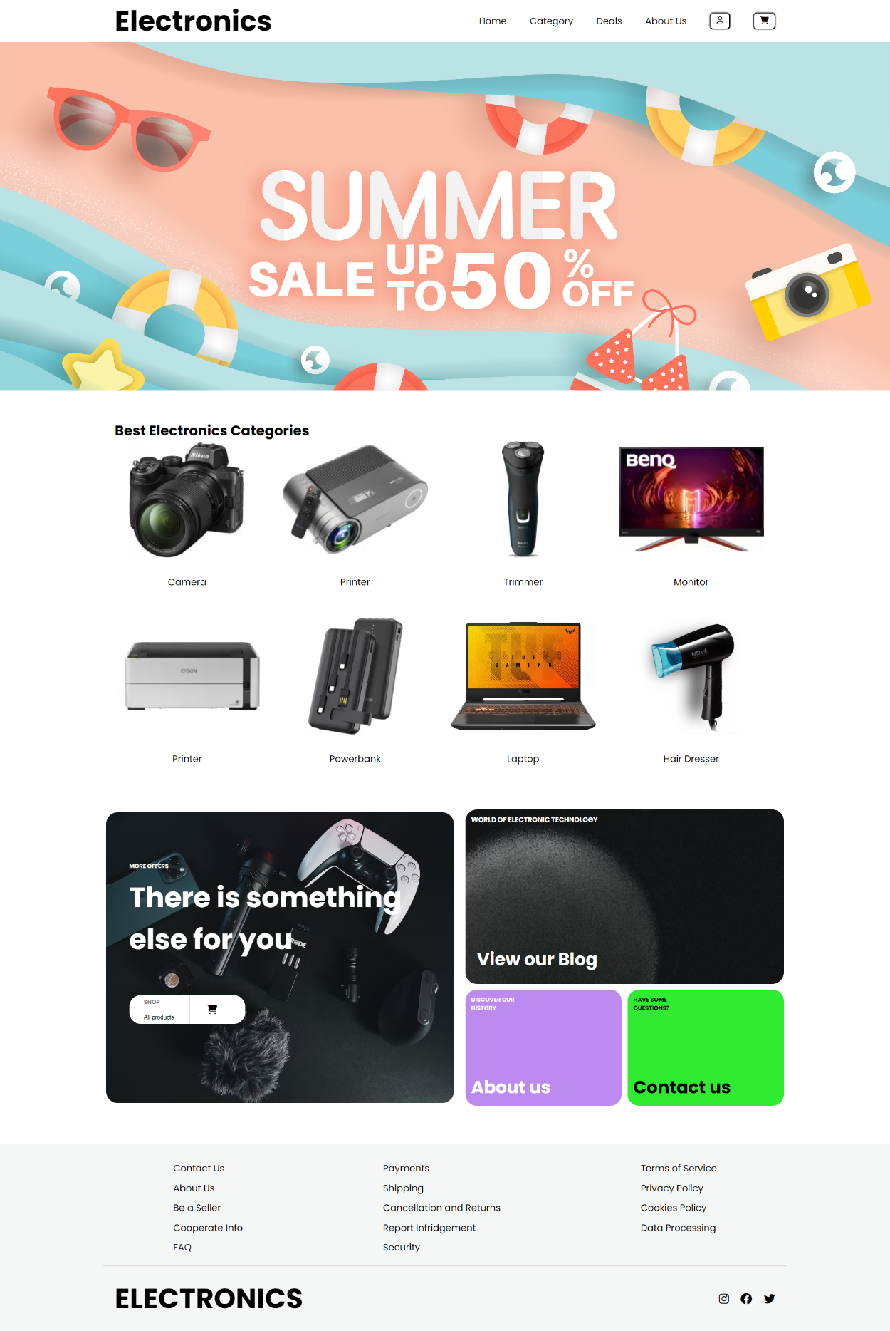**<body>:** Contains the visible content of the webpage.
* **Header (<nav>):** Displays the website logo and navigation links, including Home, Category, Deals, About Us, Sign In, and Cart.
* **Empty Deals Section (<div class="deals flex">):** Currently empty, might be intended for displaying special deals.
* **Categories Section (<div class="container category-content">):** Lists various electronics categories like Camera, Printer, Trimmer, etc., each with an image and description.
* **More Offers Section (<div class="more">):** Promotes additional offers, allowing users to shop for all products. Also, provides links to the blog, About Us, and Contact Us sections.
* **Footer (<footer>):** Contains multiple sections with links to Contact Us, About Us, seller-related information, payment, shipping, and legal policies. Also includes social media icons.
* **JavaScript Function:** A script toggles a class on the <body> element, allowing users to switch between light and dark modes.

**3.3 About Us:**

* **<body>:** Contains the visible content of the webpage, including navigation, headers, main content, and footer.

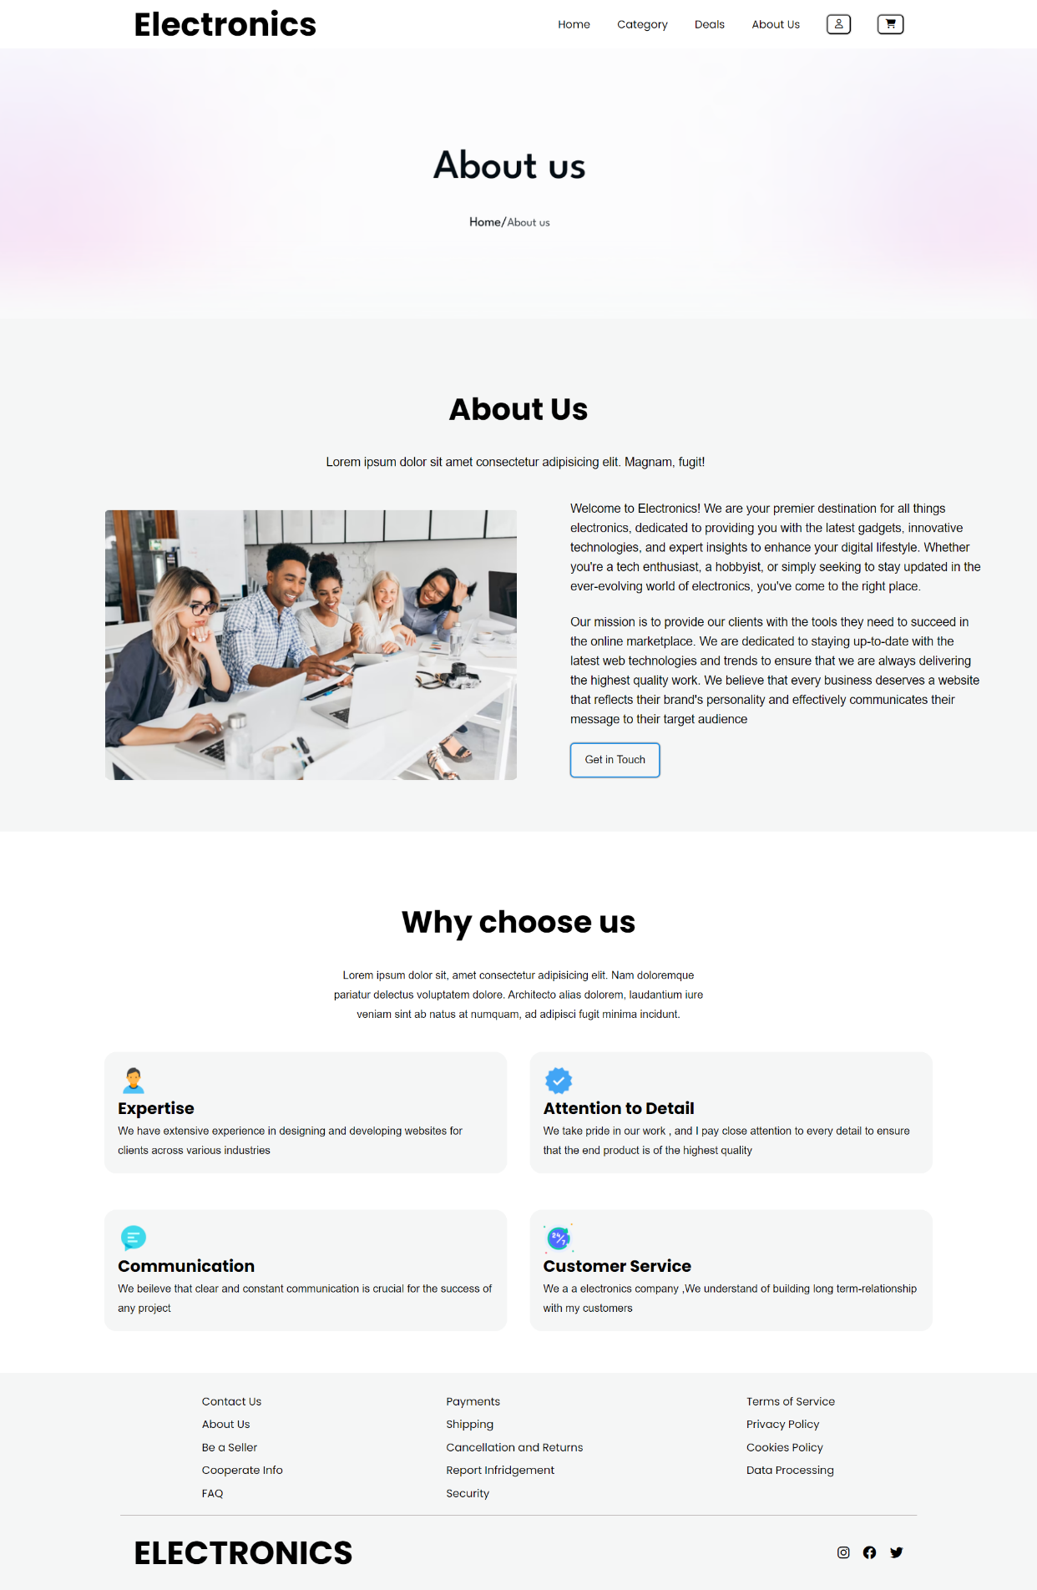

* **<nav>:** Defines the navigation bar containing links to different sections of the website and icons for user interaction.
* **<div class="header-aboutus">:** A placeholder for potential header content related to the "About Us" page.
* **<div class="main-content">:** Contains the main content of the webpage, including a brief introduction and a "Get in Touch" button.
* **<div class="main-chooseus">:** Provides reasons for visitors to choose the website's services, with brief descriptions and icons.
* **<footer>:** Contains footer content, including links to various pages (Contact Us, About Us, etc.) and social media icons.

**3.4 Category Page:**

* **<body>:** Contains the visible content of the webpage, including navigation, category selection buttons, category content, promotional information, and footer.

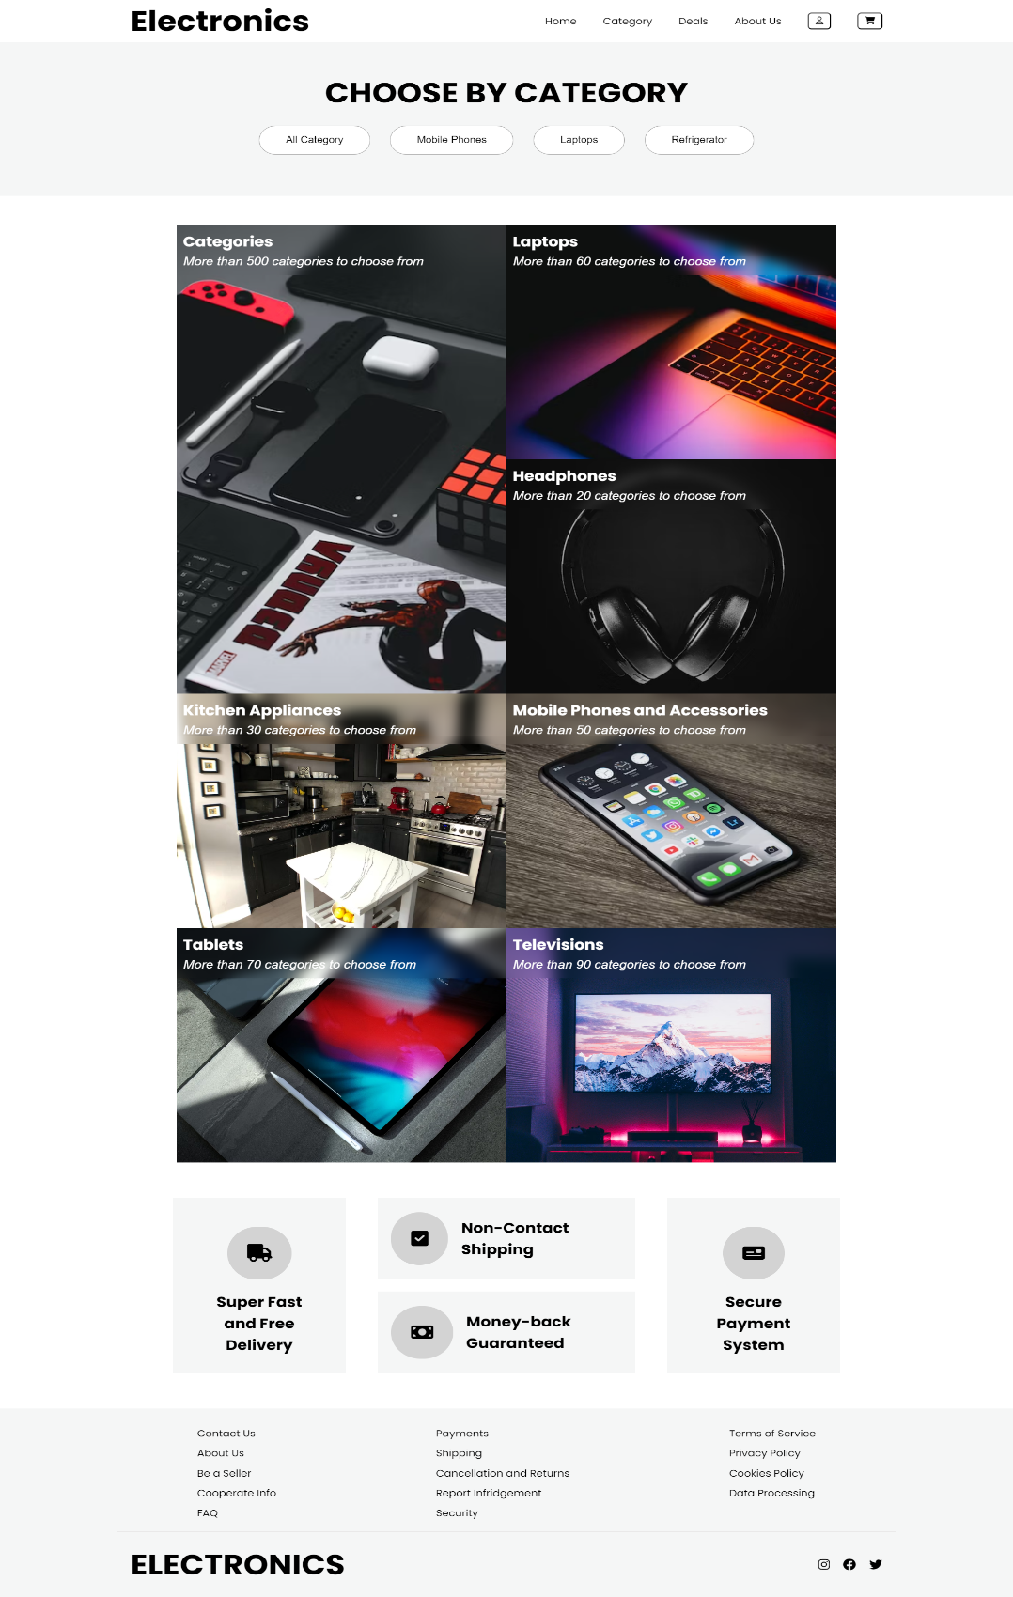

* **<nav>:** Defines the navigation bar with links to different sections of the website and buttons for user interaction.
* **<div class="content-header">:** Displays a header with the title "CHOOSE BY CATEGORY" and buttons to select different product categories.
* **<div class="category-container">:** Contains sections with links to specific product categories (like Laptops, Headphones, Kitchen Appliances, etc.).
* **<div class="promotion-container">:** Displays promotional information, including features like fast and free delivery, non-contact shipping, money-back guarantee, and secure payment system.
* **<footer>:** Contains footer content with links to various pages (Contact Us, About Us, etc.) and social media icons

**3.5 Contact Us:**

* 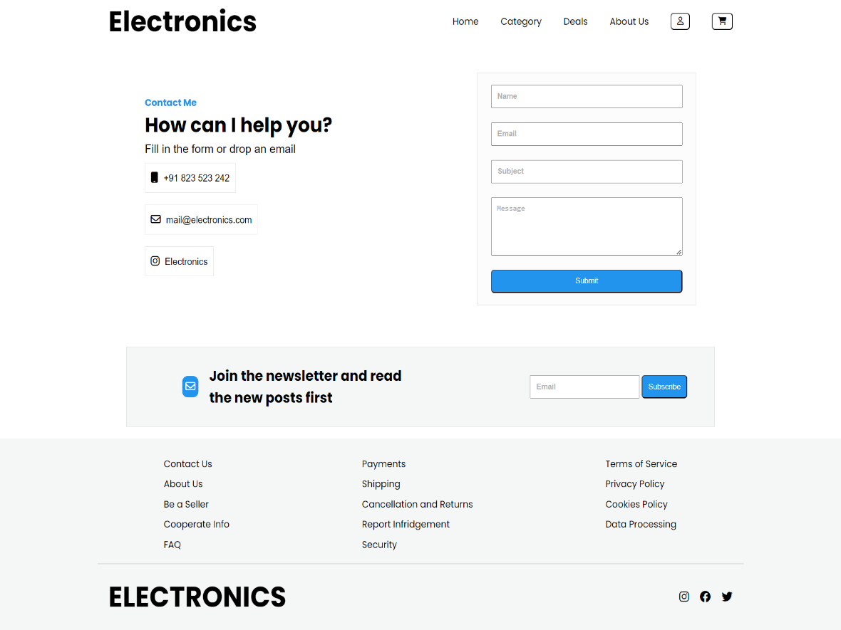**<body>:** Contains the visible content of the webpage, including navigation, contact information, a contact form, a newsletter subscription section, and a footer.
* **<nav>:** Defines the navigation bar with links to different sections of the website and buttons for user interaction.
* **<div class="contactus">:** Contains contact information and a form for users to submit inquiries.
* **<div class="newsletter">:** Provides a section for users to subscribe to a newsletter by entering their email address.
* **<footer>:** Contains footer content with links to various pages (Contact Us, About Us, etc.) and social media icons.

**3.6 Signup / Login Page:**

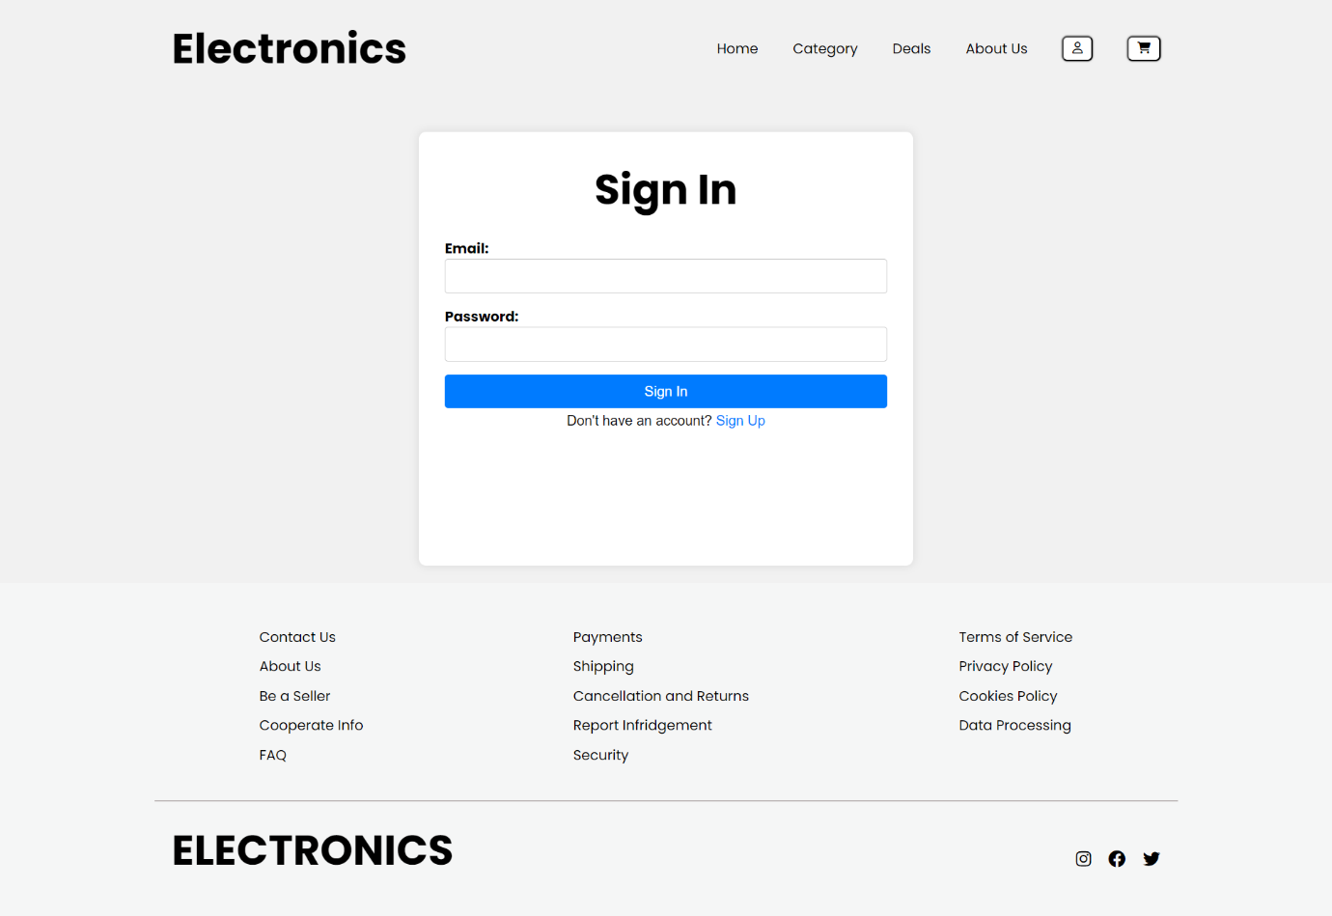

* **Navigation Bar (<nav>):** Displays the website logo and navigation links, including Home, Category, Deals, About Us. It also includes buttons for signing in and accessing the shopping cart.
* **Sign-In Form (<form class="sign-in-form">):** A form allowing users to sign in. It includes input fields for email and password. Users need to enter their email and password to sign in. There's also a link for users to navigate to the sign-up page if they don't have an account.
* 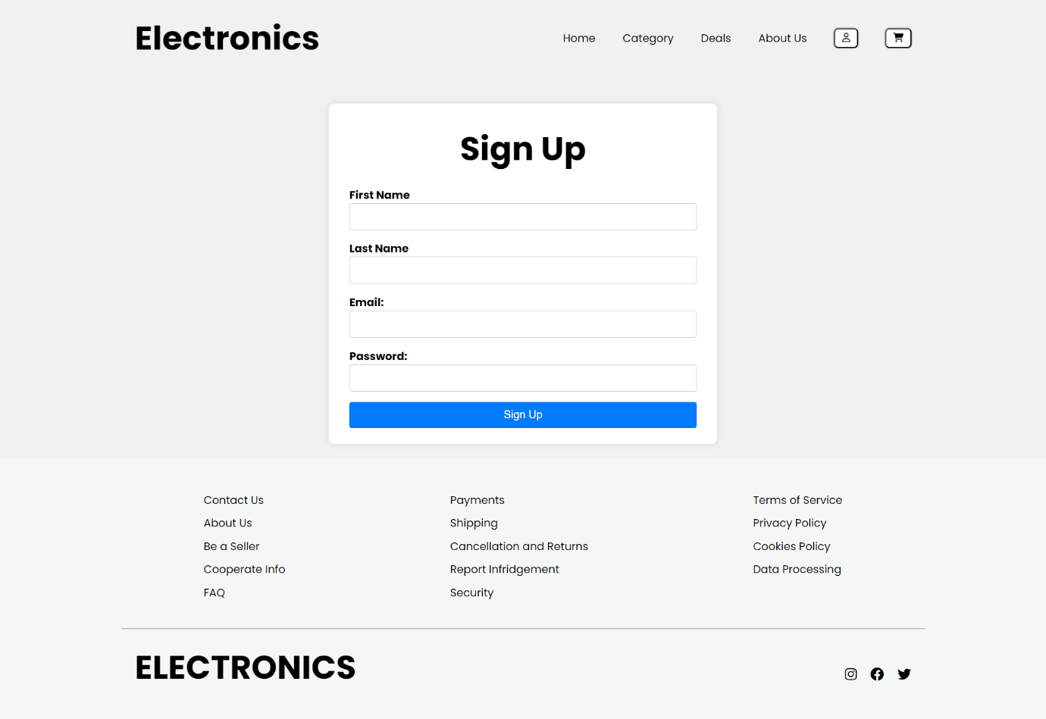**Footer (<footer>):** Contains multiple sections with links to Contact Us, About Us, seller-related information, payment, shipping, and legal policies. Also includes social media icons.
* **Navigation Bar (<nav>):** Displays the website logo and navigation links, including Home, Category, Deals, and About Us. It also includes buttons for signing in and accessing the shopping cart.
* **Sign-Up Form (<form class="sign-in-form">):** A form allowing users to sign up. It includes input fields for first name, last name, email, and password. Users need to enter their personal information to create an account.
* **Footer (<footer>):** Contains multiple sections with links to Contact Us, About Us, seller-related information, payment, shipping, and legal policies. Also includes social media icons.

3.7 Product Category Page:

* **Navigation Bar (<nav>):** Contains links to different sections of the website such as Home, Category, Deals, and About Us. It also includes buttons for user interaction like Sign In and Cart.
* **Main Video Section (<div class="main-vid">):** Displays a video with the specified source. The video is set to autoplay, muted, and in a loop, covering the entire width of its container.

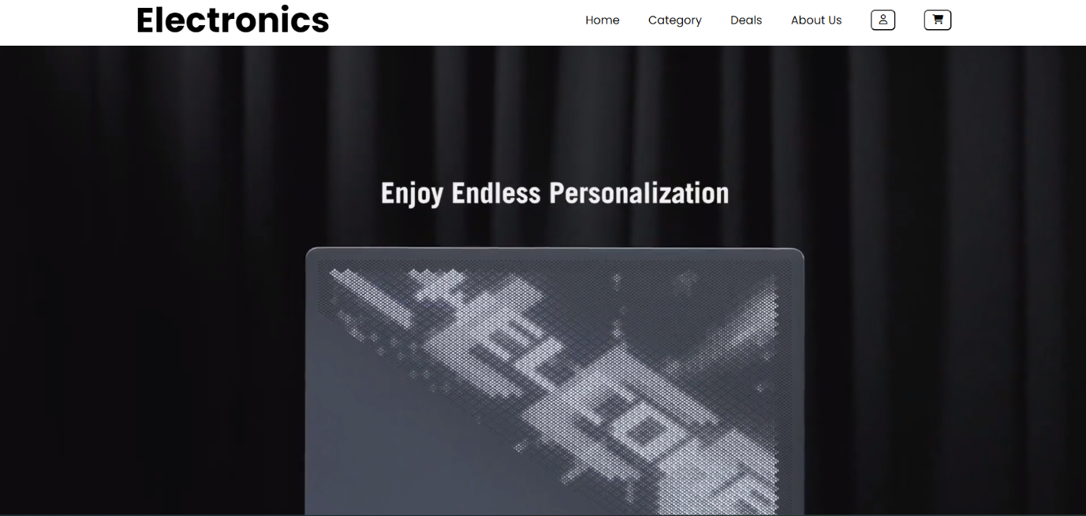

* **Laptop Brands Slider (<div class="diff-logo">):** Displays a slider showcasing different laptop brands with images. Users can navigate through the slides using control buttons.
* **Mobile Banner and New Products Section (<div class="mob-banner">, <div class="new-prod">):** Contains banners and information about newly launched products. Each product entry includes an image, description, ratings, discounted price, and a "Buy Now" button.
* 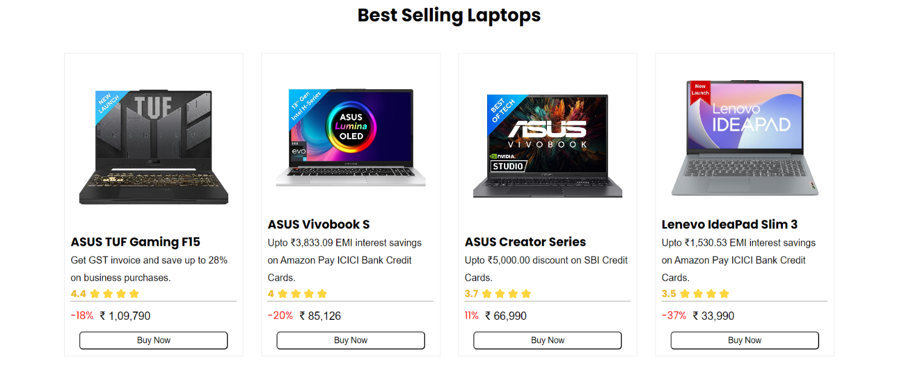**Best Selling Laptops Section (<div class="best-prod-back">):** Similar to the new products section, this part displays best-selling laptops with details and "Buy Now" buttons.
* 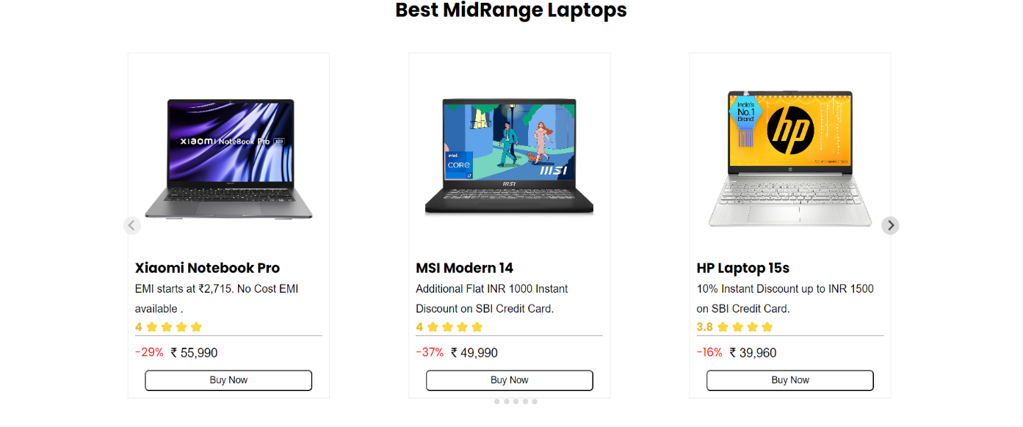**Midrange Laptops Section (<div class="splide container">):** Displays a slider showcasing mid-range laptops. Each slide includes an image, laptop details, ratings, discounted price, and a "Buy Now" button.
* **Footer Section (<footer>):** Contains links to various pages such as Contact Us, About Us, and FAQs. It also includes links related to payments, shipping, policies, and social media icons.
* **Scripts:** Includes JavaScript libraries (splide.min.js) for slider functionality and a custom JavaScript file (Laptop-Category.js) for additional interactivity.

3.8 Product Overview Page:

* **Document Structure:** The <html> element wraps the entire content of the web page. The <head> section typically contains meta-information about the document, such as its title (not included in this snippet). The <body> element contains the visible content of the web page.
* **Navigation Bar (<nav>):** The navigation bar contains links to different sections of the website. It includes links for Home, Category, Deals, About Us, Sign In, and Cart. Icons are used for the user and cart links.
* **Product Display (<div class="shop container">):** This section displays information about a specific product (SAMSUNG Galaxy Tab S9 Ultra Wi-Fi Android Tablet with 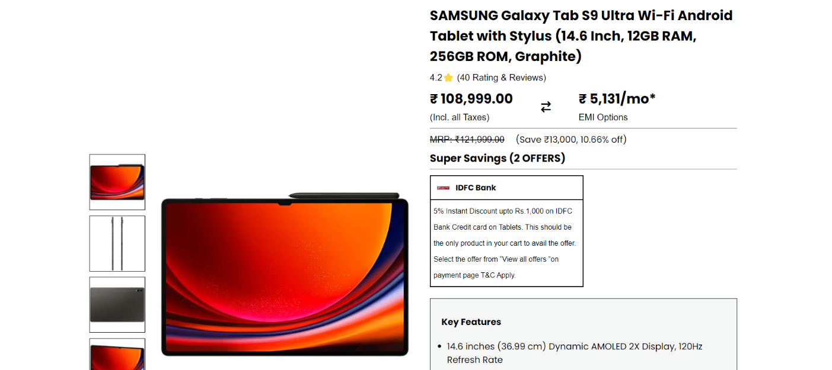Stylus) for online shopping. It includes product images, name, ratings, price details, and specifications.
* **Product Panel (<div class="shop-panel-bg">):** This section shows a smaller version of the product with a brief description and a "Buy Now" button and an "Add to Cart" button.
* **Product Details and Overview (<div class="mob-moredetails container">):** This section provides detailed information about the product, including manufacturer details, operating system, processor details, and an overview of the product's features. It also includes a video showcasing the product.

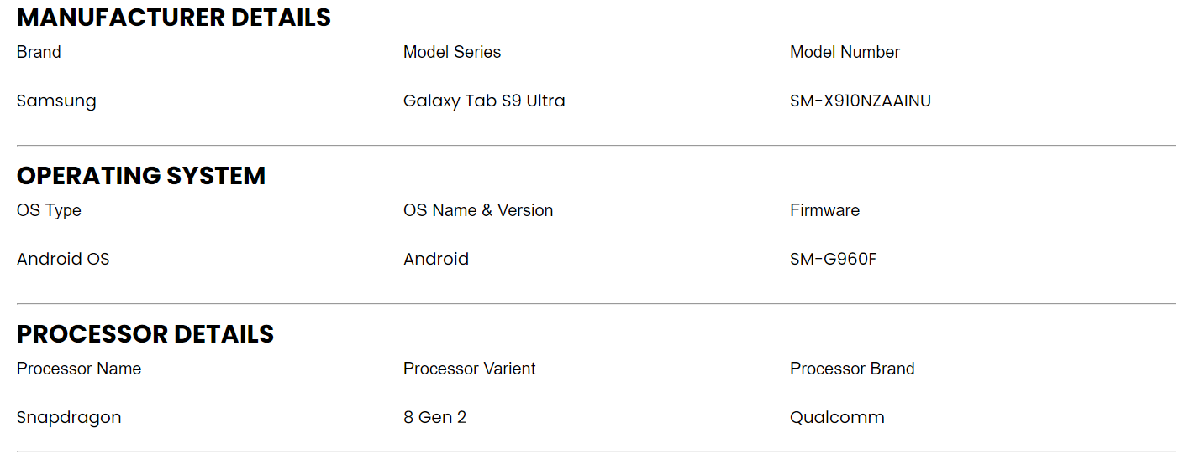

* **Footer (<footer>):** The footer section typically contains links to various pages like Contact Us, About Us, FAQs, and policy-related links such as Terms of Service, Privacy Policy, etc. Social media icons for Instagram, Facebook, and Twitter are included in the footer.
* **Script Inclusion:** The JavaScript file "Tablet-Shop1.js" is included at the end, suggesting there might be some interactivity or dynamic behavior associated with the web page, likely handled by JavaScript.

**3.9 Cart Page:**

* 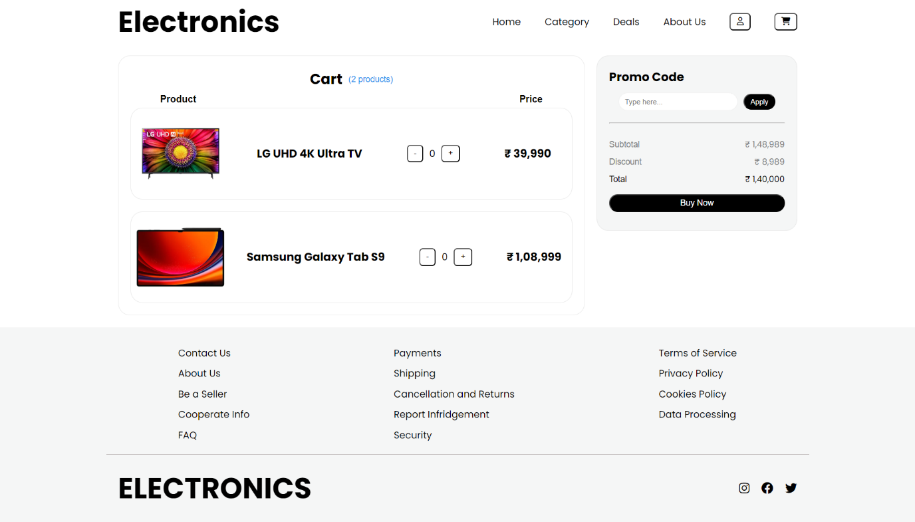**Cart Content (<div class="cart container">):** The cart section displays products added by the user. Each product includes an image, product name, quantity adjustment buttons, and price. Subtotal, discount, and total price are calculated and displayed. There is an input field for applying promo codes.
* **Footer (<footer>):** The footer contains various links such as Contact Us, About Us, Be a Seller, and FAQs. It also includes links related to payments, shipping, cancellation, and privacy policies. Social media icons for Instagram, Facebook, and Twitter are included.
* **Scripts:** The page includes JavaScript libraries (splide.min.js) for handling interactive elements like sliders. A custom JavaScript file (Cart.js) is included, indicating there might be dynamic behavior or interactivity associated with the cart functionality.

**CHAPTER 4: WHY CHOOSE NAME “ELECTRONICS”?**

The choice of the name "ELECTRONICS" for your e-commerce site can be influenced by several factors:

* **Focus on Electronics:** If your e-commerce store specializes in electronic products such as smartphones, laptops, tablets, cameras, and other electronic gadgets, naming it "ELECTRONICS" clearly communicates your niche and the type of products you offer.
* **Clarity and Simplicity:** The name "ELECTRONICS" is straightforward and easy to remember. It conveys the nature of the products without ambiguity, making it easier for potential customers to understand what your store sells.
* **Brand Image:** Choosing a specific and clear name like "ELECTRONICS" can help in building a strong brand image. Customers looking for electronic products may find the name appealing and memorable.
* **Search Engine Optimization (SEO):** A domain name that includes a relevant keyword like "electronics" can potentially improve your website's search engine ranking when people search for electronic products online.
* **Versatility:** While the primary focus is on electronics, the name "ELECTRONICS" doesn't limit you to a specific subset of electronic products. It allows you the flexibility to expand your product range within the electronics category.
* **Global Appeal:** The term "electronics" is universally understood, making your website accessible to a wide international audience.

**CHAPTER 5: Future Scope**

* **Mobile App Development:** Consider developing a dedicated mobile application for "APPLIANCES" to provide a seamless and optimized shopping experience for mobile users.
* **Personalization and AI:** Implement advanced personalization techniques and artificial intelligence to provide customers with product recommendations, personalized content, and a tailored shopping experience.
* **Progressive Web App (PWA):** Transform your website into a PWA to offer offline access, push notifications, and a more app-like experience for users.
* **Augmented Reality (AR) Integration:** Allow customers to visualize appliances in their own space using AR technology, which can enhance the decision-making process.
* **Voice Commerce:** Enable voice search and voice-assisted shopping for hands-free browsing and ordering through voice-activated devices.
* **Subscription Models:** Introduce subscription services for regular appliance maintenance, filter replacements, or exclusive access to new products.
* **Global Expansion:** Consider expanding your e-commerce platform to serve customers in different regions and countries to tap into a broader market.
* **Cross-Selling and Upselling:** Develop cross-selling and upselling strategies to increase the average order value by recommending related products or premium versions.
* **Enhanced Analytics and Data Insights:** Utilize advanced analytics tools to gain insights into user behaviour, sales patterns, and inventory management, which can guide business decisions.
* **Social Commerce:** Integrate social media features to allow users to discover products through social networks, share their purchases, and interact with your brand on social platforms.